ALLAHABAD

City Map

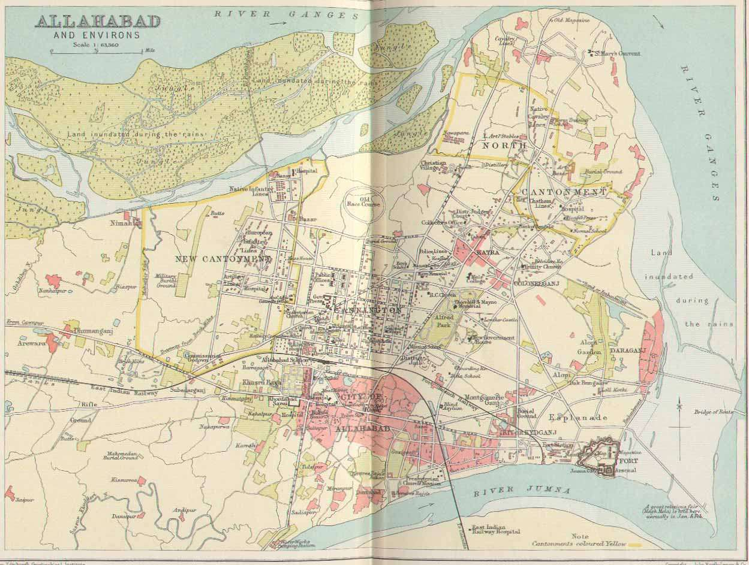

Cemetery One – The Cantonment Cemetery

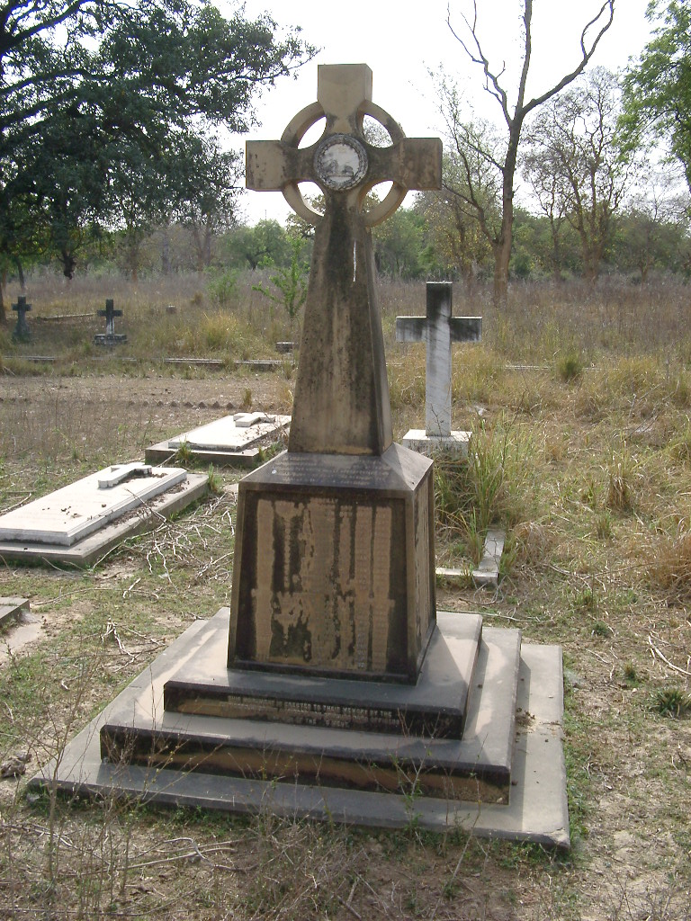 |  | 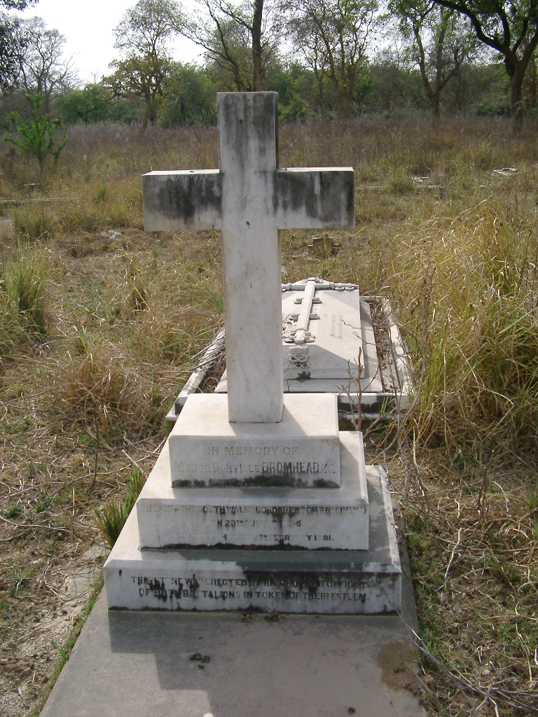
The South Wales Borderers’ Memorial lists the wives and children who died while the Regiment was in India |  | The Grave of Major Gonville Bromhead VC, hero of Rorke’s Drift, who died of typhoid in Allahabad in February 1891

